SCHOOL

Year 12 Trial WACE Examination, 2013

Question/Answer Booklet

MATHEMATICS: SPECIALIST 3C/3D
SOLUTIONS

Section Two:

Calculator-assumed

Student Number: In figures

In words

Your name

Time allowed for this section
Reading time before commencing work: ten minutes
Working time for this section: one hundred minutes

Materials required/recommended for this section

To be provided by the supervisor
This Question/Answer Booklet
Formula Sheet (retained from Section One)

To be provided by the candidate
Standard items: pens, pencils, pencil sharpener, eraser, correction fluid/tape, ruler, highlighters

Special items: drawing instruments, templates, notes on two unfolded sheets of A4 paper, and up to three calculators satisfying the conditions set by the Curriculum Council for this examination.

Important note to candidates

No other items may be used in this section of the examination. It is your responsibility to ensure that you do not have any unauthorised notes or other items of a non-personal nature in the examination room. If you have any unauthorised material with you, hand it to the supervisor before reading any further.

Structure of this paper

Section | Number of questions available | Number of questions to be answered | Working time (minutes) | Marks available | Percentage of exam
Section One:  Calculator-free | 7 | 7 | 50 | 50 | 33
Section Two:  Calculator-assumed | 13 | 13 | 100 | 100 | 67
 |  |  | Total | 150 | 100

Instructions to candidates

- The rules for the conduct of Western Australian external examinations are detailed in the Year 12 Information Handbook 2013. Sitting this examination implies that you agree to abide by these rules.

- Write your answers in the spaces provided in this Question/Answer Booklet. Spare pages are included at the end of this booklet. They can be used for planning your responses and/or as additional space if required to continue an answer.
- Planning: If you use the spare pages for planning, indicate this clearly at the top of the page.
- Continuing an answer: If you need to use the space to continue an answer, indicate in the original answer space where the answer is continued, i.e. give the page number. Fill in the number of the question(s) that you are continuing to answer at the top of the page.

- Show all your working clearly. Your working should be in sufficient detail to allow your answers to be checked readily and for marks to be awarded for reasoning. Incorrect answers given without supporting reasoning cannot be allocated any marks. For any question or part question worth more than two marks, valid working or justification is required to receive full marks. If you repeat an answer to any question, ensure that you cancel the answer you do not wish to have marked.

- It is recommended that you do not use pencil, except in diagrams.

Section Two: Calculator-assumed (100 Marks)
This section has thirteen (13) questions. Answer all questions. Write your answers in the spaces provided.

Working time for this section is 100 minutes.

Question 8 (5 marks)
(a) Determine the exact coordinates of the image of point with coordinates 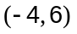 after an anti-clockwise rotation of 120° about the origin. (2 marks)
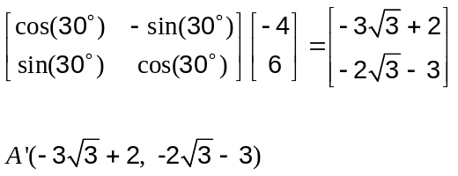

(b) A plane figure 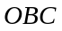 of area 35 cm² is transformed geometrically by matrix 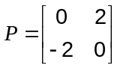 and then by matrix 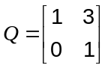.

(i) Describe geometrically the effect of transformation matrix 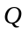. (1 mark)

A shear of factor 3 parallel to the -axis.

(ii) Calculate the single matrix that represents the combined effect of transformation by matrix followed by matrix . (1 mark)
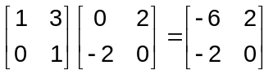

(iii) Calculate the area of the plane figure after the two transformations. (1 mark)

Question 9 (6 marks)
Anders is planning to take part in a race involving kayaking and running. All contestants must leave the start at A, on the bank of a straight canal and paddle their kayak across the river to an arbitrary point P, m from point C which is directly across the river from the start. When they reach the opposite bank at P, contestants must run to the finish at B.
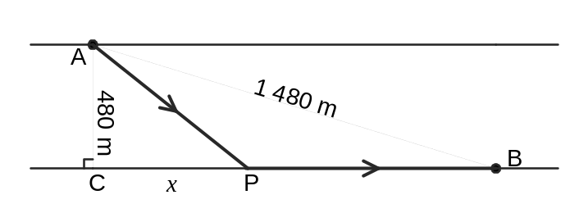
The canal is 480 m wide and the straight line distance from the start to finish is 1 480 m.

Anders can kayak at a constant speed of 4 ms⁻¹ and run at a constant speed of 5 ms⁻¹.

(a) Explain why his time to complete the race is given by 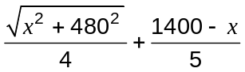 seconds.
(2 marks)

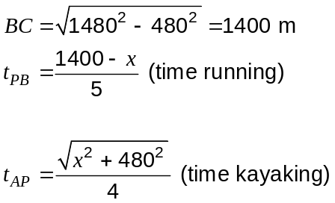

(b) Use a calculus method to determine the shortest possible race time for Anders. (4 marks)
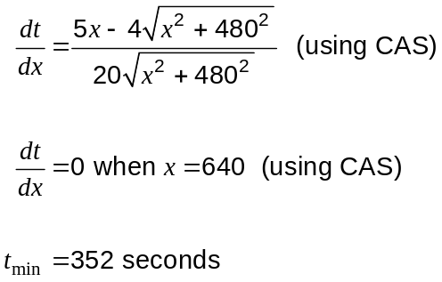

Question 10 (8 marks)
A function is defined as 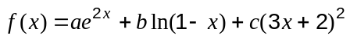, where , and are real constants.
(a) Given that 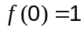, 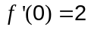 and 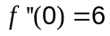, find the matrix 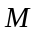 such that 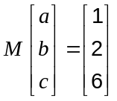.
(5 marks)
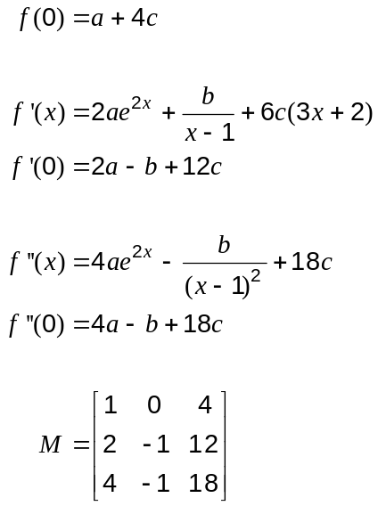

(b) Determine 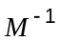 and show use of a matrix method to find the values of , and .
(3 marks)
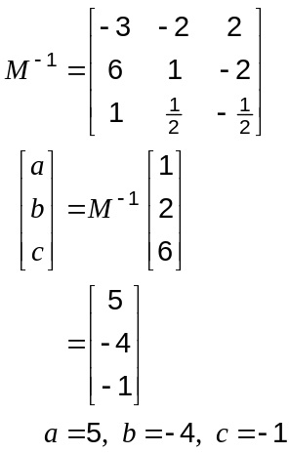

Question 11 (8 marks)
Consider the parametric equations of the path of a surveillance drone relative to the stationary operator:
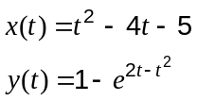 for 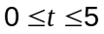.

North is in the direction of the positive-axis, time is measured in minutes and all distances are in kilometres.

(a) Determine the distance of the drone from the operator when 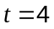. (2 marks)
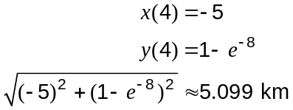

(b) Show that the drone is flying due West when 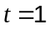. (3 marks)

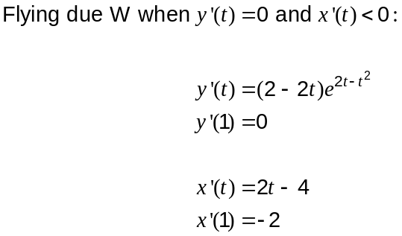

(c) How far is the drone from the operator at the instant that it is flying due North? (3 marks)

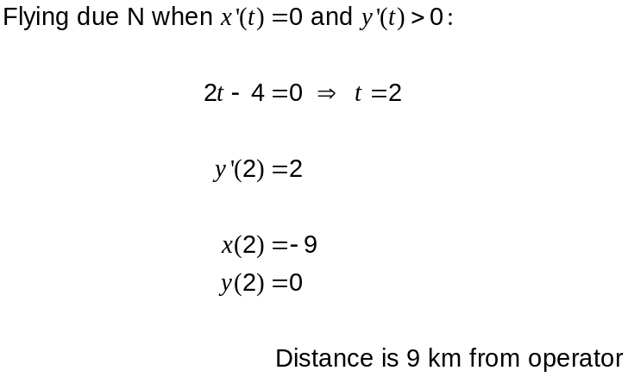

Question 12 (7 marks)
As part of a scientific investigation, a cold object was placed in an underground room where the temperature is a constant 12°C. At 3 pm the temperature of the object is measured to be 5°C, at which instant it is moved to an upstairs room that is maintained at a constant temperature of 23°C.

(a) The temperature of the object in the upstairs room can be modelled by the equation 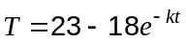 where is the temperature of the object in degrees Celsius, is the time in hours since the object was placed in the room and is a constant.

After one hour in the upstairs room the temperature of the object is 13°C.

Show that 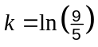. (3 marks)
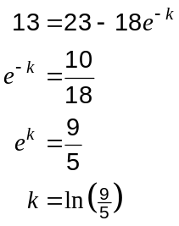

(b) Before the object was moved upstairs, its temperature in the underground room was modelled by an equation of the form 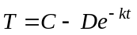, with the same constant .

At what time of day, to the nearest minute, was the temperature of the object in the underground room 0°C? (4 marks)

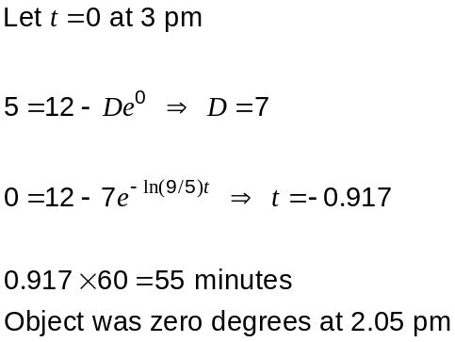

Question 13 (7 marks)
As part of an investigation into Kepler's third law, a group of astronomy students produced the graph of the linear relationship shown below. is the average radius of a planet's orbit around the sun, in millions of kilometres, and is the period of that orbit in years.
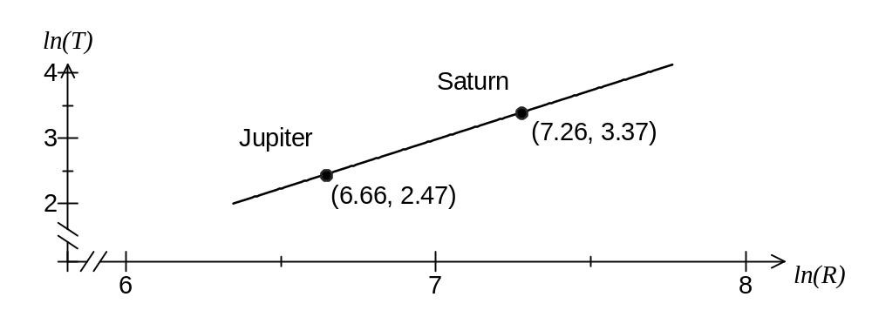
(a) The relationship between and can be modelled by 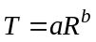.

Show that this model can also be expressed in the form 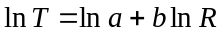. (2 marks)

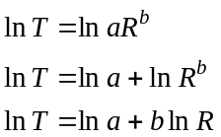

(b) Determine the gradient and vertical axis intercept for the straight line through the two points shown on the above graph and hence state the values of and . (4 marks)

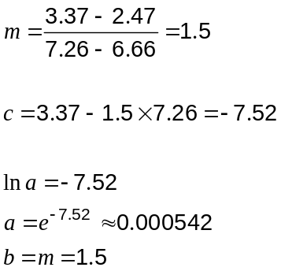

(c) Use the model to calculate the period of Mars, given that it has an average orbit of radius 227.9 million km. (1 mark)

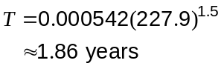

Question 14 (8 marks)
A group of triathletes trained in just one of three disciplines every day - running (R), swimming (S) or cycling (C). The trainer of the group set the following days discipline based on chance and drew the diagram at right in the changing rooms.  For example, the diagram shows that if the group swam today, there is a 65% chance that they would cycle, a 15% chance that they would run and a 20% chance that they would swim on the following day. | 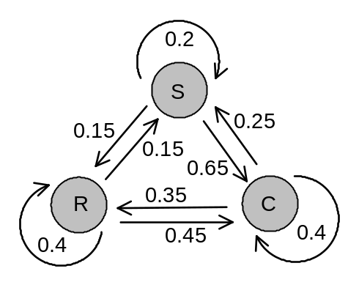

(a) Complete the transition matrix, T, below which corresponds to this drawing. (2 marks)

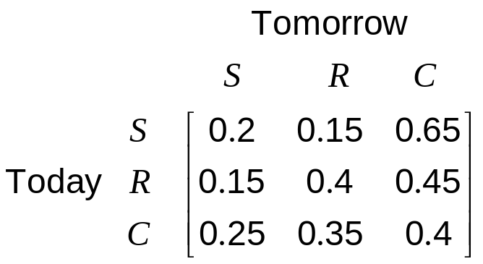

(b) The group cycle on Sunday. What is the probability that three days later, on Wednesday, they run? Round your answer to 4 decimal places. (3 marks)

Require element 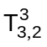, which is 0.325375 or 0.3254 to 4 dp.

(c) The group swim on Friday.

(i) Write down a matrix calculation that will result in a one-by-one matrix, whose single element is the probability that the group cycle on Friday, two weeks later.
(2 marks)
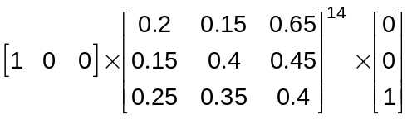

(ii) What is this probability? (1 mark)
0.468 (to 3 dp)

Question 15 (13 marks)
The points P, Q and R have position vectors 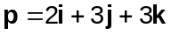, 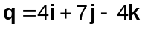 and 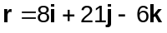 respectively, relative to the origin. The point S has position vector and is such that PQRS is a parallelogram.

(a) Find the position vector of relative to the origin. (2 marks)

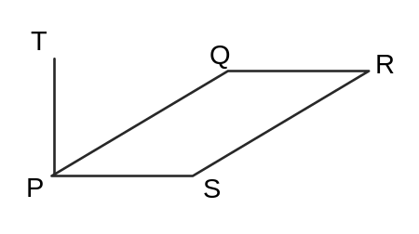
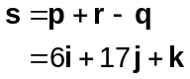

(b) Calculate the lengths of PQ and QR, the size of angle PQR and hence the area of the parallelogram. (4 marks)

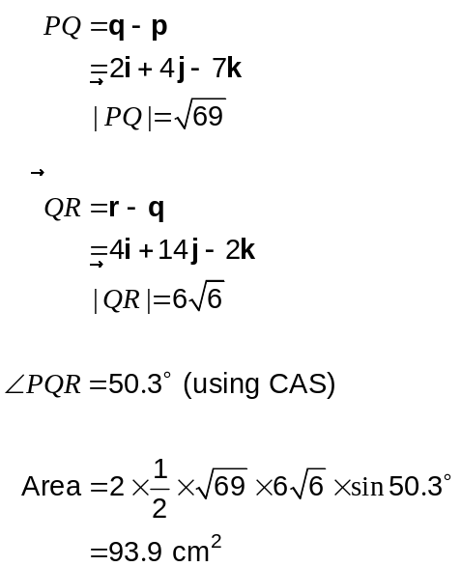

(c) Show that the vector 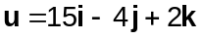 is perpendicular to the plane containing the parallelogram. (3 marks)

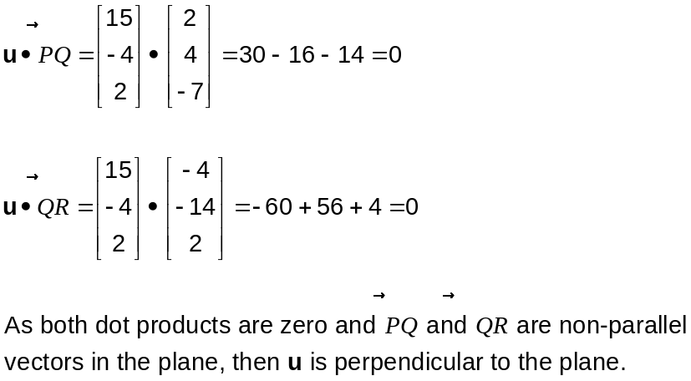

(d) The point T with position vector 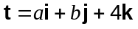 lies on the line that is perpendicular to the plane, through P. Determine the volume of the pyramid PQRST. (4 marks)
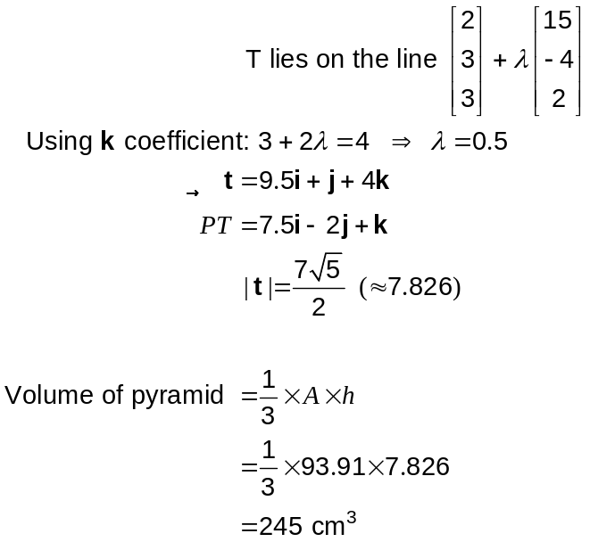
Question 16 (7 marks)
(a) Sketch the polar graphs of 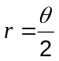 and 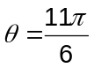 on the axes below for 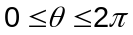. (3 marks)

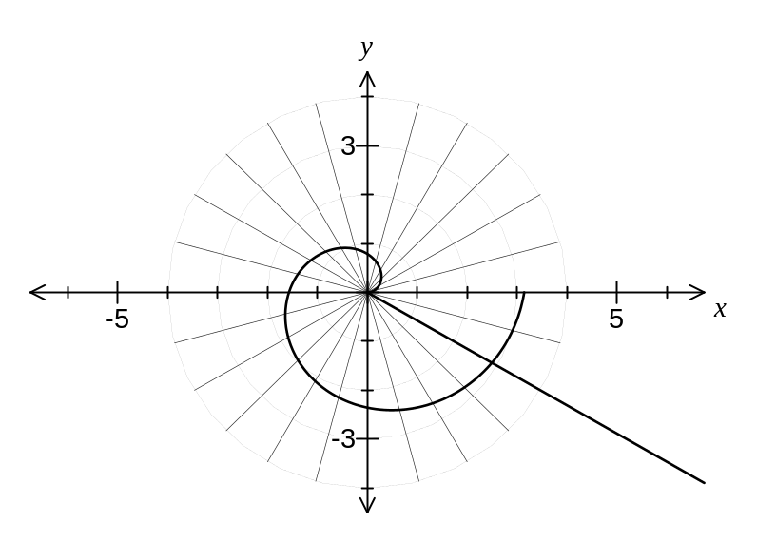

(b) is the point of intersection of the graphs of and , .
State the polar coordinates of . (1 mark)

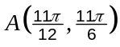

(c) The triangle 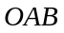 is equilateral, where 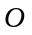 is the origin, and the graph of 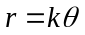 passes once through for . Determine the value(s) of . (3 marks)

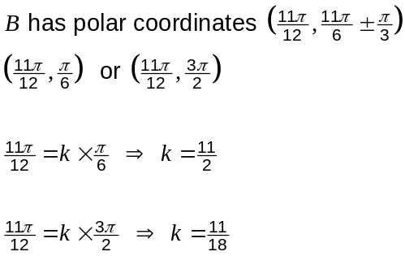

Question 17 (9 marks)
A small particle,, describes simple harmonic motion along a straight line with centre . Two points, and , lie on this straight line with between and such that 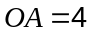cm and 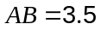cm. At the speed of the particle is 22.5 cms⁻¹ and at its speed is 12 cms⁻¹.

Determine

(a) the amplitude of the motion (3 marks)
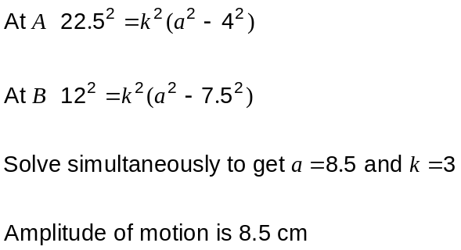

(b) the period of the motion (1 mark)
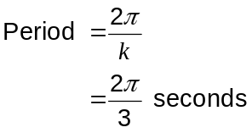

(c) the maximum speed of (2 marks)
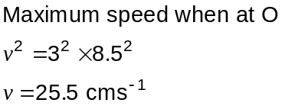

(d) the time to travel from to (3 marks)
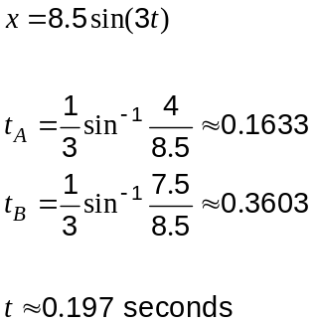

Question 18 (7 marks)
Sketch the following regions in the complex plane.

(a) 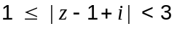. (4 marks)
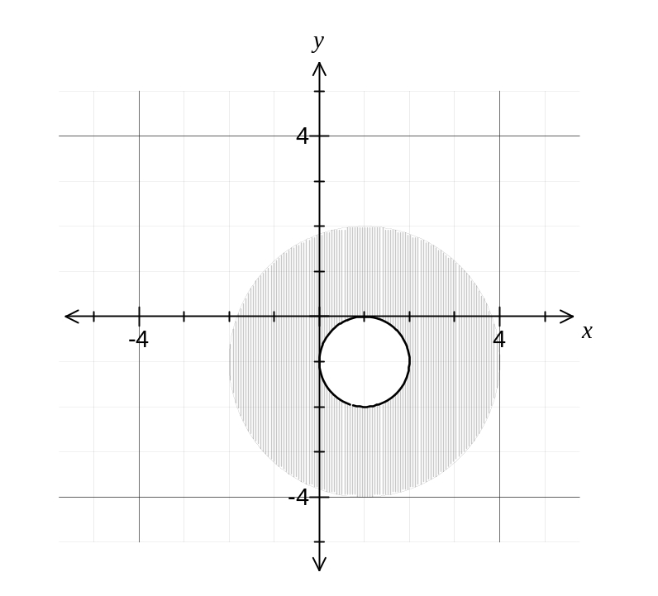
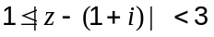

(b) 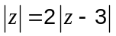. (3 marks)
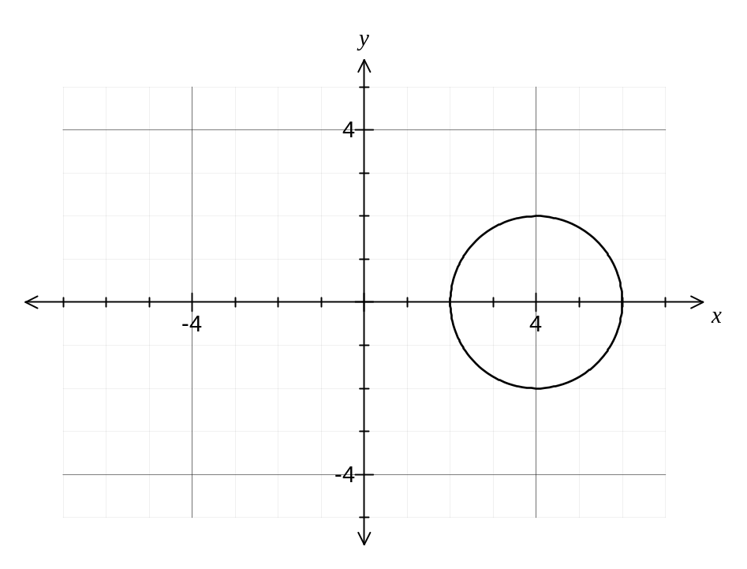
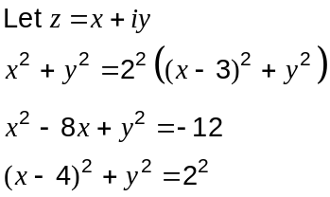

Question 19 (8 marks)
(a) Prove by deduction that . (2 marks)

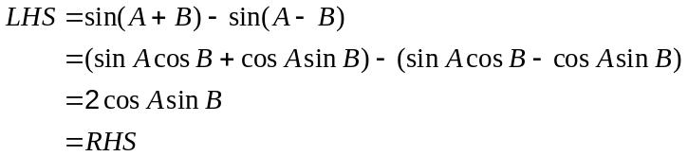

(b) Prove by induction that 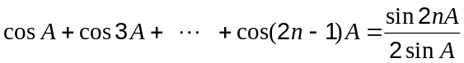 for integers 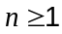.
(6 marks)
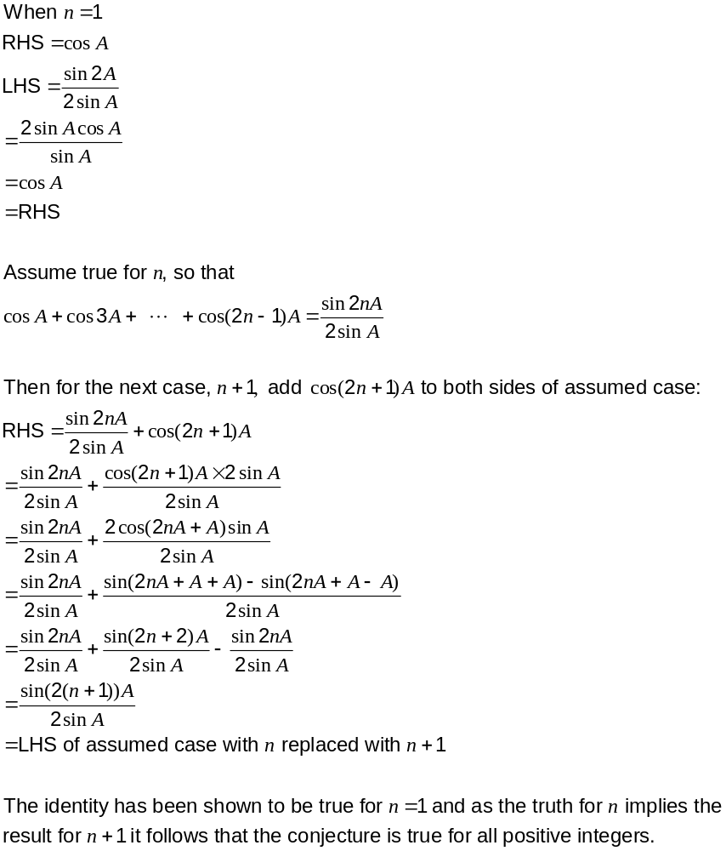

Question 20 (7 marks)

The natural logarithm of can be expressed as 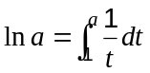.

(a) Express the natural logarithm of 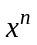 in the same way. (1 mark)
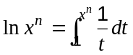

(b) Let 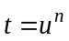.

(i) Find 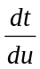. (1 mark)
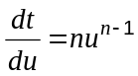

(ii) Find the value of when and when 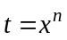. (2 marks)

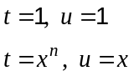

(c) Use the substitution in your expression from (a) to deduce that 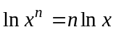.
(3 marks)

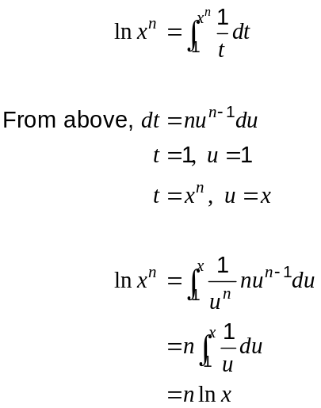

Additional working space

Question number: _________

Additional working space

Question number: _________

Additional working space

Question number: _________

This examination paper may be freely copied, or communicated on an intranet, for non-commercial purposes within educational institutes that have purchased the paper from WA Examination Papers provided that WA Examination Papers is acknowledged as the copyright owner. Teachers within purchasing schools may change the paper provided that WA Examination Paper's moral rights are not infringed.

Copying or communication for any other purposes can only be done within the terms of the Copyright Act or with prior written permission of WA Examination papers.

Published by WA Examination Papers
PO Box 445 Claremont WA 6910

